Cold Wallet
# Source: AI Source: Provided by: [Data Path: Persons Table -> ID Column: 1, Name_En Column: Motasem Essam] -> From: [ChatGPT] on [1/21/2026]
A Cold Wallet is a cryptocurrency wallet that is kept offline, meaning it is not connected to the internet during key storage or signing. It is designed for maximum security, making it ideal for long-term storage of large cryptocurrency holdings.

❄️ Key Characteristics of Cold Wallets:
# Source: AI Source: Provided by: [Data Path: Persons Table -> ID Column: 1, Name_En Column: Motasem Essam] -> From: [ChatGPT] on [1/21/2026]
- Offline by Design
  - Keeps private keys completely disconnected from the internet to protect against hacking and malware.
- Manual Transaction Signing
  - Transactions are usually signed offline and then broadcast separately via an online device.
- Highest Security Standard
  - Immune to online attacks, phishing, or software-based keyloggers.
- Used for "HODLing"
  - Best suited for users who plan to hold (HODL) crypto long-term without frequent access.

🧊 Types of Cold Wallets:
# Source: AI Source: Provided by: [Data Path: Persons Table -> ID Column: 1, Name_En Column: Motasem Essam] -> From: [ChatGPT] on [1/21/2026]

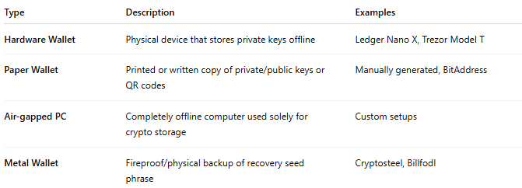

Type | Description | Examples
Hardware Wallet | Physical device that stores private keys offline | Ledger Nano X, Trezor Model T
Paper Wallet | Printed or written copy of private/public keys or QR codes | Manually generated, BitAddress
Air-gapped PC | Completely offline computer used solely for crypto storage | Custom setups
Metal Wallet | Fireproof/physical backup of recovery seed phrase | Cryptosteel, Billfodl

🛠️ How It Works (e.g., Hardware Wallet):
# Source: AI Source: Provided by: [Data Path: Persons Table -> ID Column: 1, Name_En Column: Motasem Essam] -> From: [ChatGPT] on [1/21/2026]

- Create Wallet on the device (generates keys offline).
- Store recovery seed phrase securely (backup of keys).
- When sending crypto:
  - Create transaction on online device.
  - Transfer it to the cold wallet to sign (offline).
  - Transfer back to broadcast it online.

✅ Advantages:
# Source: AI Source: Provided by: [Data Path: Persons Table -> ID Column: 1, Name_En Column: Motasem Essam] -> From: [ChatGPT] on [1/21/2026]
- Very secure (offline = unhackable remotely)
- Ideal for storing large amounts of crypto
- Keeps keys in user’s full control
- Resistant to viruses, malware, keyloggers

⚠️ Disadvantages:
# Source: AI Source: Provided by: [Data Path: Persons Table -> ID Column: 1, Name_En Column: Motasem Essam] -> From: [ChatGPT] on [1/21/2026]
- Less convenient for frequent transactions
- Physical loss or damage can result in loss of funds (if backups are also lost)
- Requires more technical knowledge for secure setup and usage
- Paper wallets and air-gapped systems can be harder to manage

🧠 Best Use Cases:
# Source: AI Source: Provided by: [Data Path: Persons Table -> ID Column: 1, Name_En Column: Motasem Essam] -> From: [ChatGPT] on [1/21/2026]
- Long-term investors and HODLers
- Institutions managing cold storage reserves
- High-value accounts needing maximum protection

🆚 Hot Wallet vs Cold Wallet Comparison
# Source: AI Source: Provided by: [Data Path: Persons Table -> ID Column: 1, Name_En Column: Motasem Essam] -> From: [ChatGPT] on [1/21/2026]
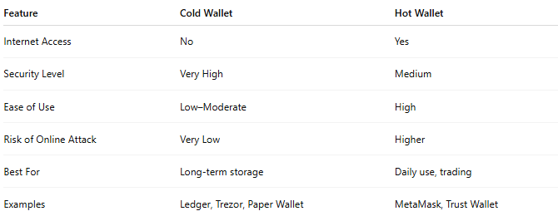

Feature | Cold Wallet | Hot Wallet
Internet Access | No | Yes
Security Level | Very High | Medium
Ease of Use | Low–Moderate | High
Risk of Online Attack | Very Low | Higher
Best For | Long-term storage | Daily use, trading
Examples | Ledger, Trezor, Paper Wallet | MetaMask, Trust Wallet

🔐 Cold Wallet Security Tips:
# Source: AI Source: Provided by: [Data Path: Persons Table -> ID Column: 1, Name_En Column: Motasem Essam] -> From: [ChatGPT] on [1/21/2026]
- Always backup your recovery seed phrase and store it in a safe place.
- For hardware wallets, only buy from official vendors (to avoid tampering).
- Don’t take photos of your seed phrase or store it online.
- Use metal backups for added fire/water resistance.

